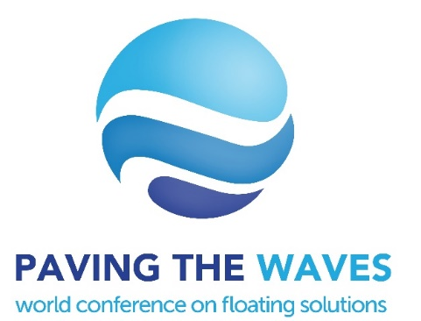

Title Bolded, 14-point Times New Roman, centered

Contact author’s name (first name last name, spell out): 12 point Times New Roman, bolded
Contact author’s affiliation and full mailing address: 12-point Times New Roman, centered, italicized
Contact author’s email address: 12-point Times New Roman, centered, italicized

Second author’s name (first name last name, spell out): 12 point Times New Roman, bolded
Second author’s affiliation and full mailing address: 12-point Times New Roman, centered, italicized
Second author’s email address: 12-point Times New Roman, centered, italicized

Abstract – Your abstract should be submitted in English and should not be more than 300 words. It should be an explicit summary of your presentation that states the problem, the methods used, and the major results and conclusions. Do not include reference citation, scientific symbols, acronyms, numbers, bullets or lists in the abstract. It should be single-spaced in 12-point Times New Roman. Your abstract should include the problem statement and the rationale for pursuing the project, the research problem and question, the identified research gap, methodology used to address the problems, highlights of the results obtained and finally close with a statement of project’s implications and contributions to its field. It should convince readers that the project is interesting, valuable, and worth investigating further. The content of the abstract will be the basis for acceptance of the paper presentation at the World Conference on Floating Solutions 2020. The abstracts will be peer reviewed and authors will be informed about acceptance for presentation via email.

Keywords – Put keywords here (maximum 5 keywords. each keywords is separated by a comma).

Corresponding Author’s Brief Professional Biography

This biography should be no more than 150 words and should describe the contact author’s professional credentials, background, experience and research interests/initiatives. Please also provide a photo of the corresponding author
Corresponding Author’s Photo (35mm wide × 45mm height)

